Lab Assignment 1.2 – AI Assisted Coding
P. Manikanta 2403A51L52 B: 52

Task 0: GitHub Copilot Installation & Configuration

Steps Followed:
- Installed Visual Studio Code
- Opened Extensions Marketplace
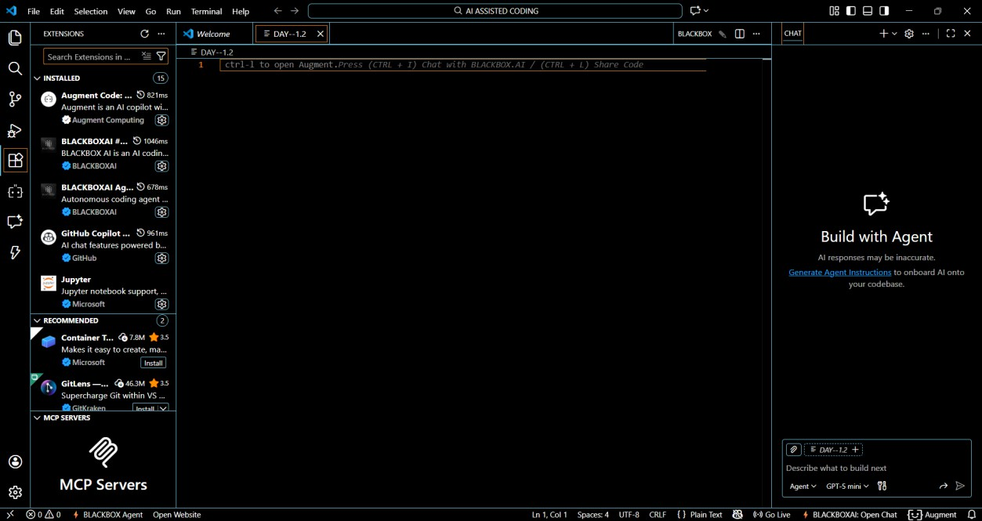
- Searched for GitHub Copilot

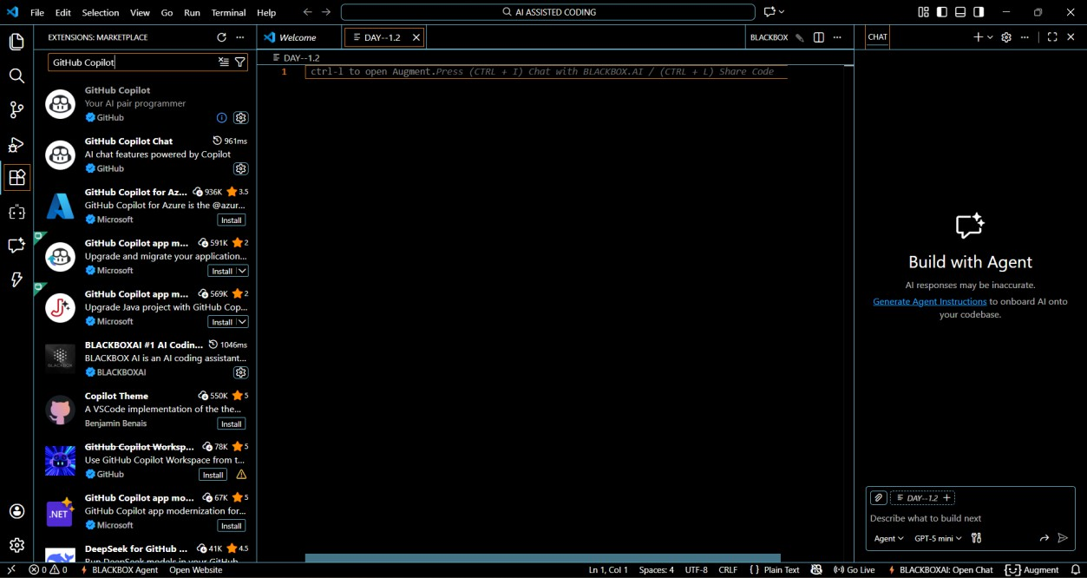
- Clicked Install
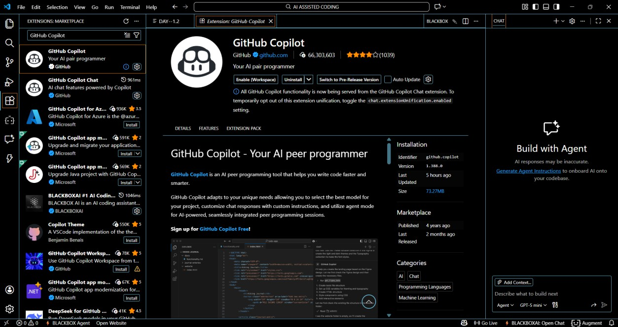
- Signed in with GitHub Account
- Enabled Copilot suggestions
- Verified Copilot inline suggestions in Python file

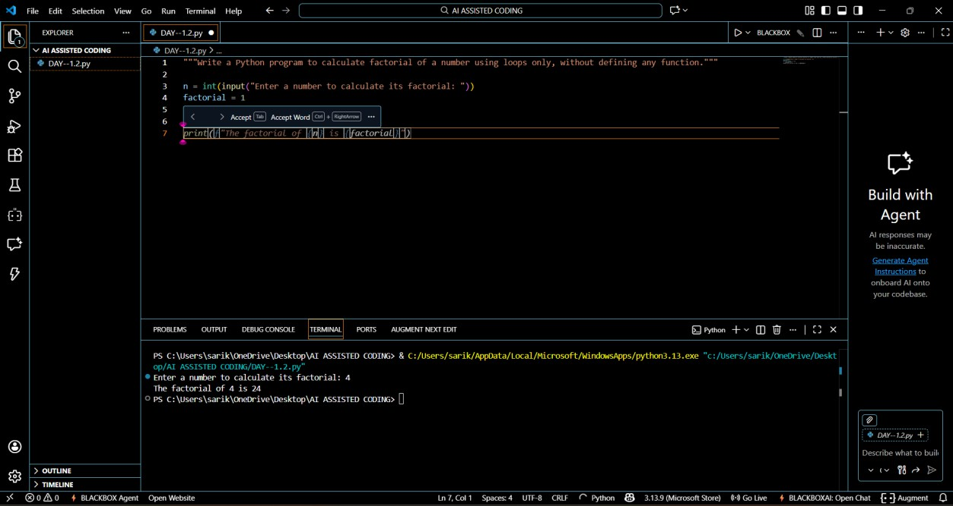

Task 1: AI-Generated Logic Without Modularization
(Factorial without Functions)
Prompt Used: “Write a Python program to calculate factorial of a number using loops only, without defining any function.”
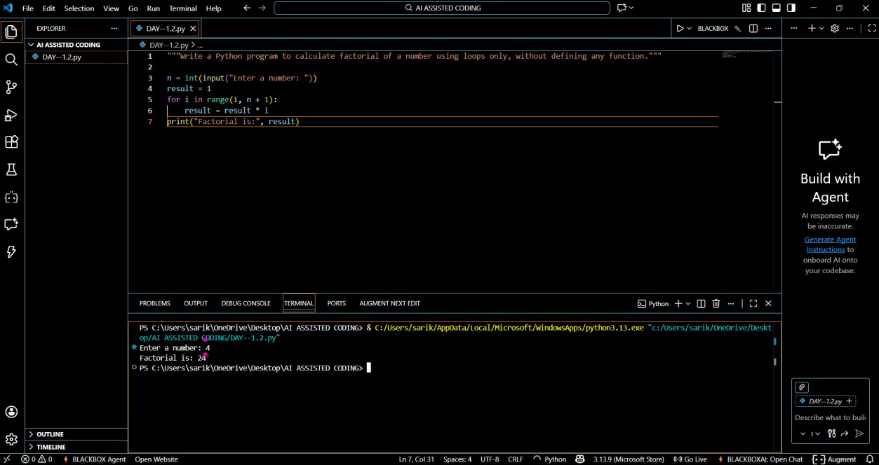
GitHub Copilot was very helpful for a beginner as it generated correct logic instantly.
It followed basic Python syntax and loop structure accurately.

The code was readable and easy to understand.
However, it did not include input validation automatically.
Best practices like modular design were not applied unless explicitly prompted.

Task 2: AI Code Optimization & Cleanup
Original Code:

Prompt Used: “Optimize this code and make it more readable”

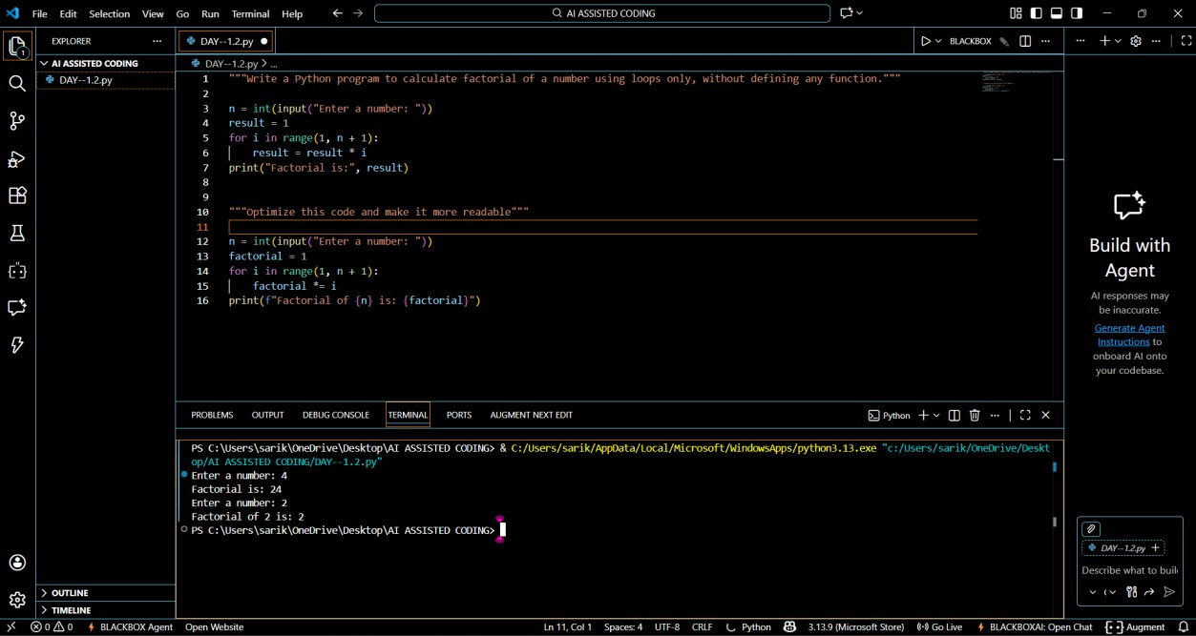
The optimized version improves clarity, maintainability, and readability without affecting performance.

Task 3: Modular Design Using AI Assistance (Factorial with Functions)
Prompt Used: “Create a Python function to calculate factorial and call it from main block”
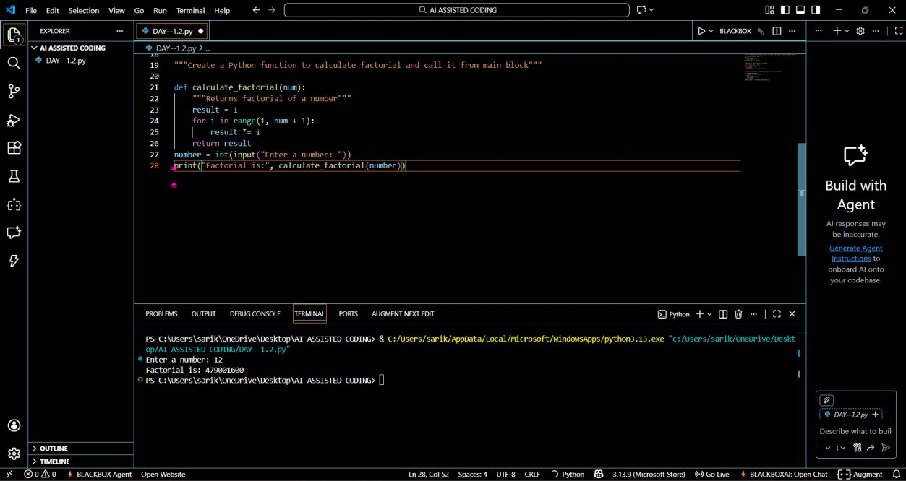

Modularity improves reusability by allowing the same function to be used across multiple programs. It also simplifies testing and
debugging.

Task 4: Comparative Analysis
Procedural vs Modular AI Code

Criteria Without
Function

With Function

Logic Clarity Moderate High
Reusability No Yes
Debugging Ease Difficult Easy Large Project Suitability Poor Excellent AI Dependency Risk Higher Lower

Conclusion:
Function-based design is more scalable and suitable for real-world applications.

Task 5: Iterative vs Recursive AI Code
Prompt Used: “Generate iterative and recursive factorial programs in Python”

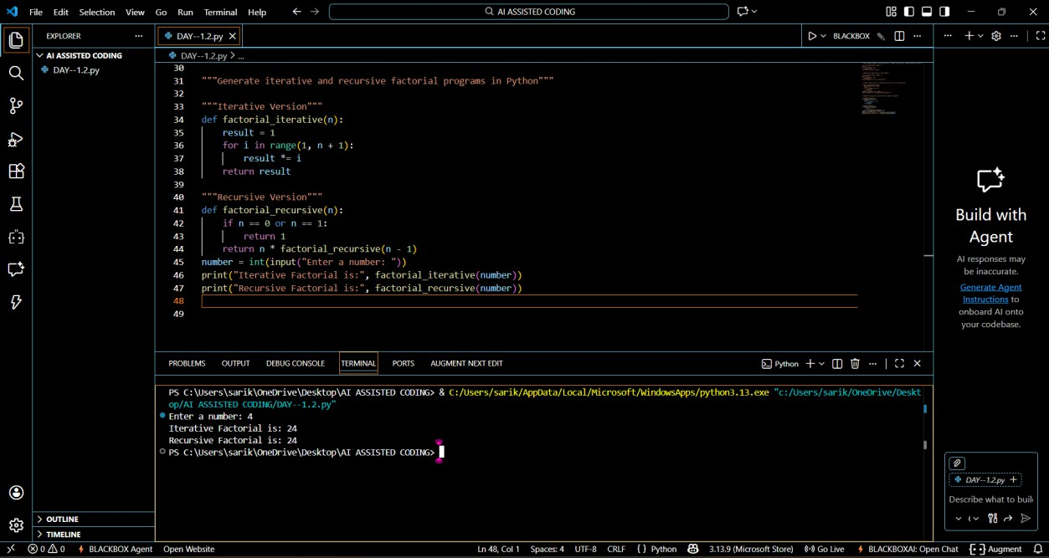

Execution Flow Explanation:
- Iterative version uses a loop and constant memory.
- Recursive version uses function calls and stack memory.

Comparison:

Aspect | Iterative | Recursive
Readability | Simple | Elegant
Stack Usage | No | Yes
Performance | Faster | Slower
Risk | Low | Stack Overflow
Recommendation Preferred Avoid for large
inputs

